**1. What is MSM, blueprint, live copy and rollout?**

• MSM (Multi-Site Manager): AEM’s feature that allows content reuse across multiple sites while maintaining centralized control.

• Blueprint: The master site that serves as a reference for creating multiple Live Copies.

• Live Copy: A site or page created from a Blueprint that can inherit or modify content based on the parent.

• Rollout: The process of synchronizing changes from the Blueprint to its Live Copies.

**2. What is language copy?**

A Language Copy in AEM is a localized version of a site or page created for different languages. Unlike Live Copies, Language Copies are independent and can be manually translated or integrated with automated translation tools.

**3. Create a site using MSM and us/en should be the source.**

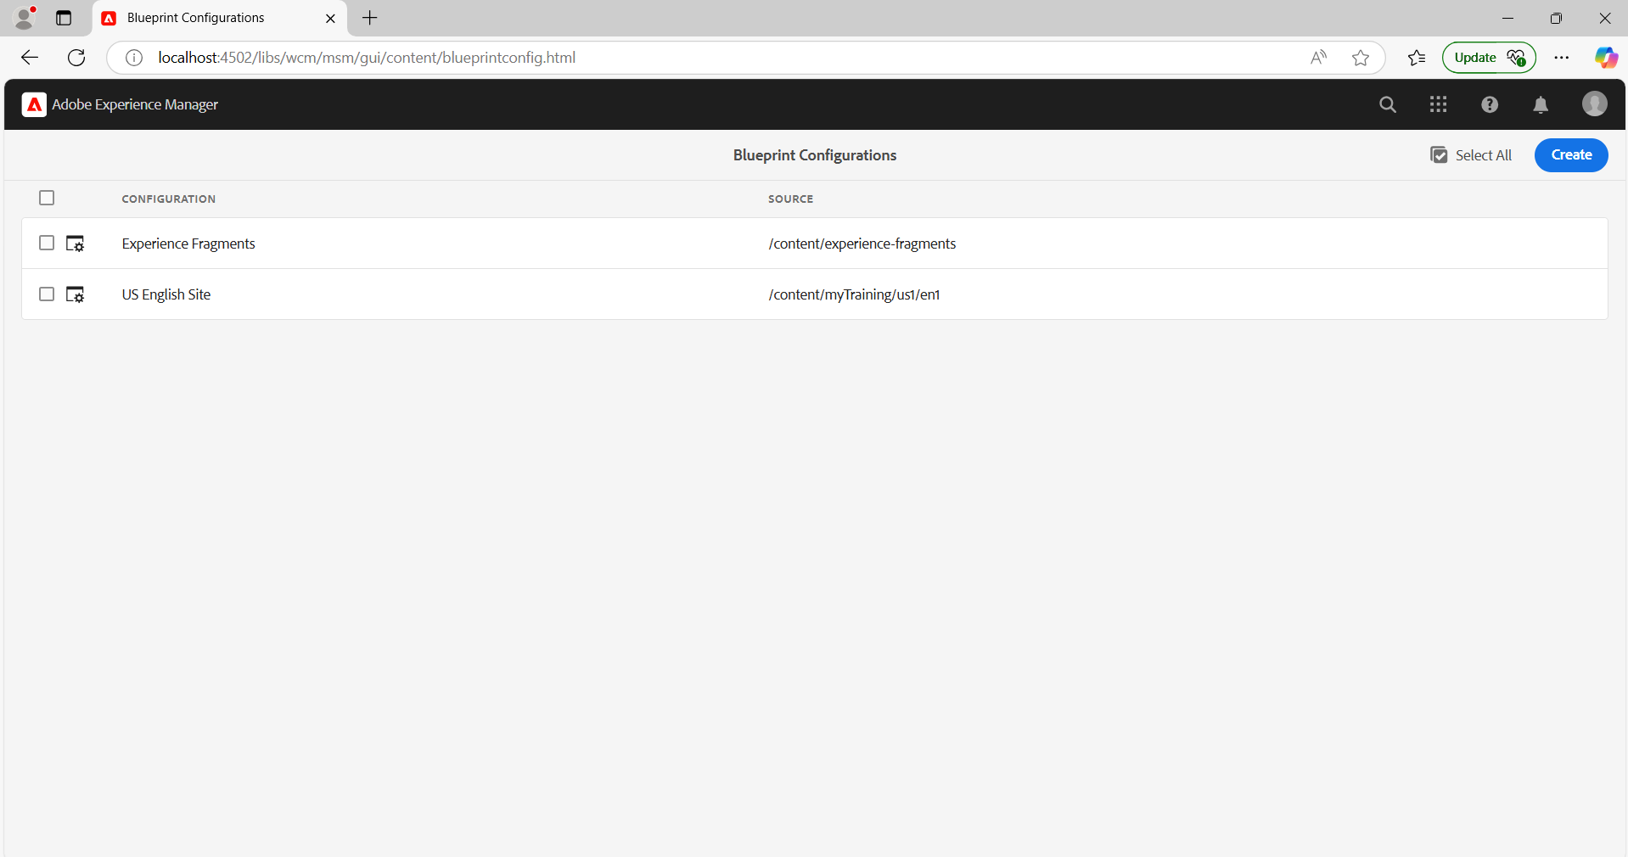

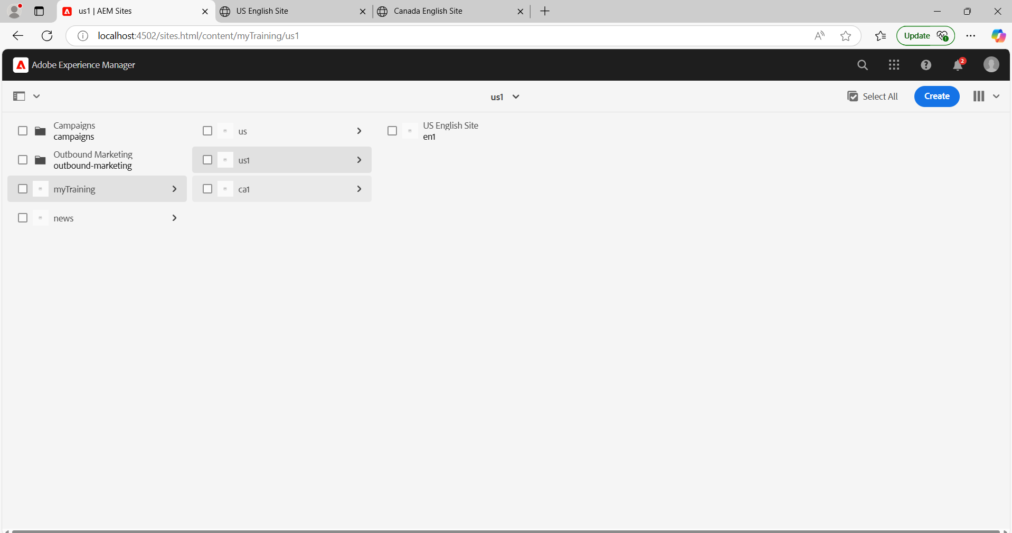

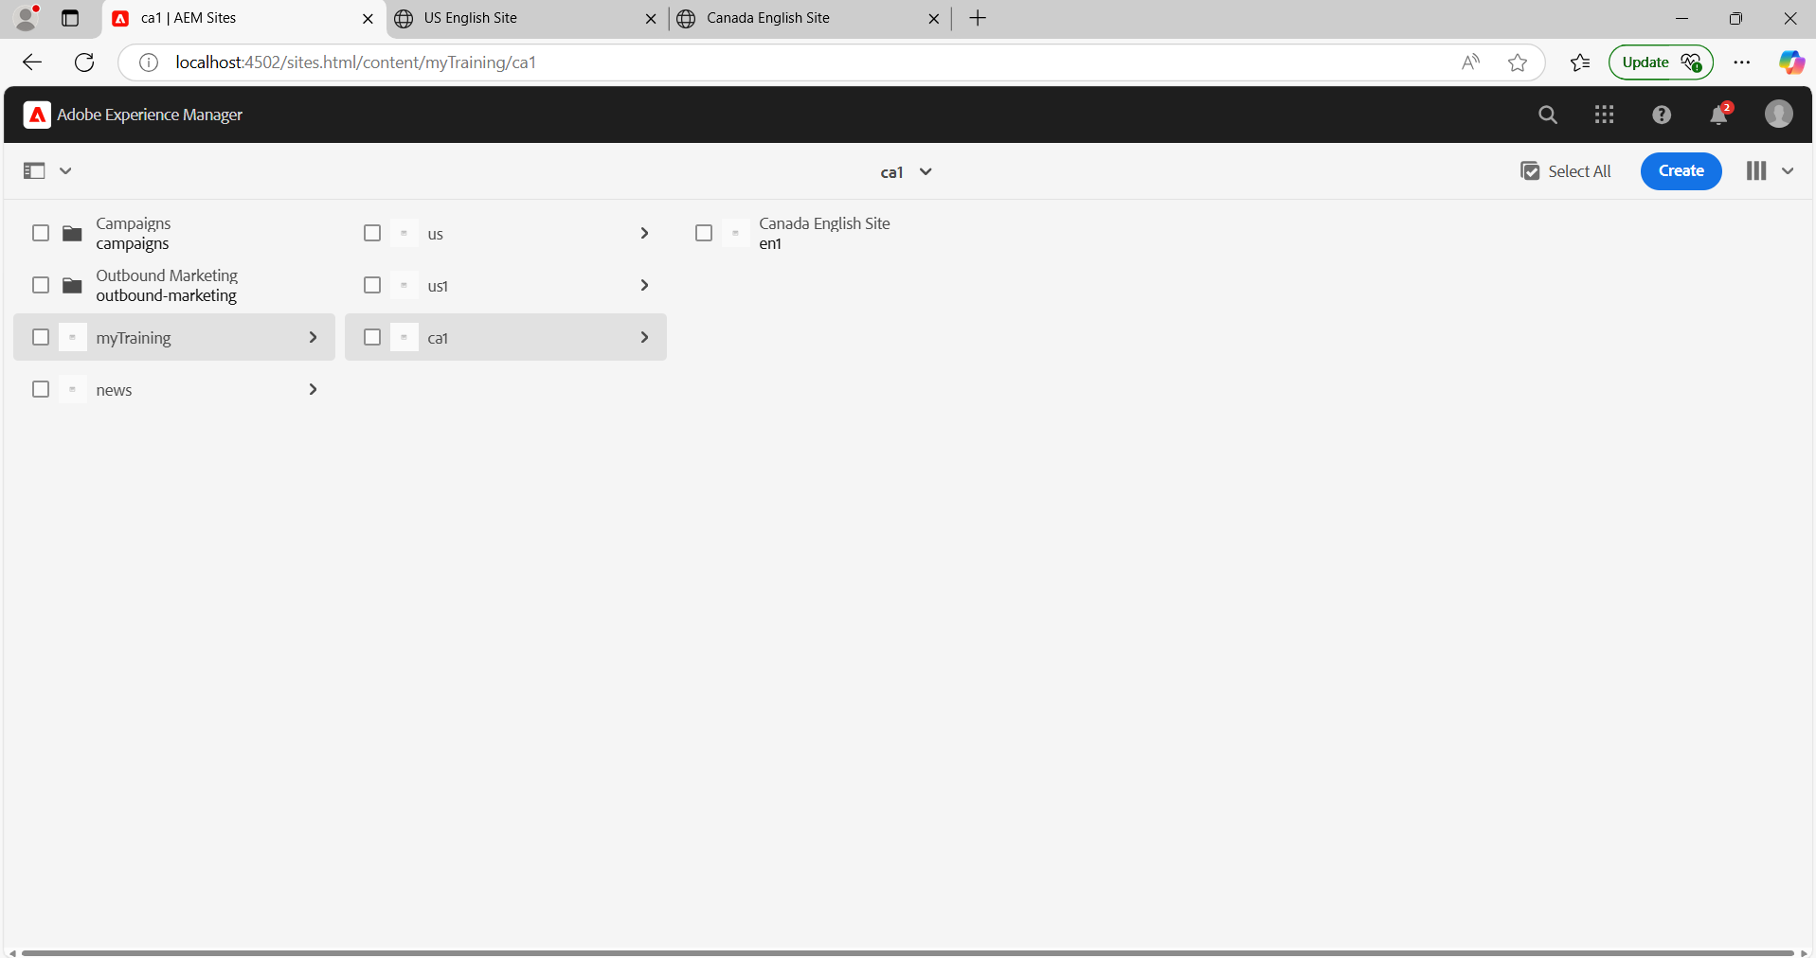

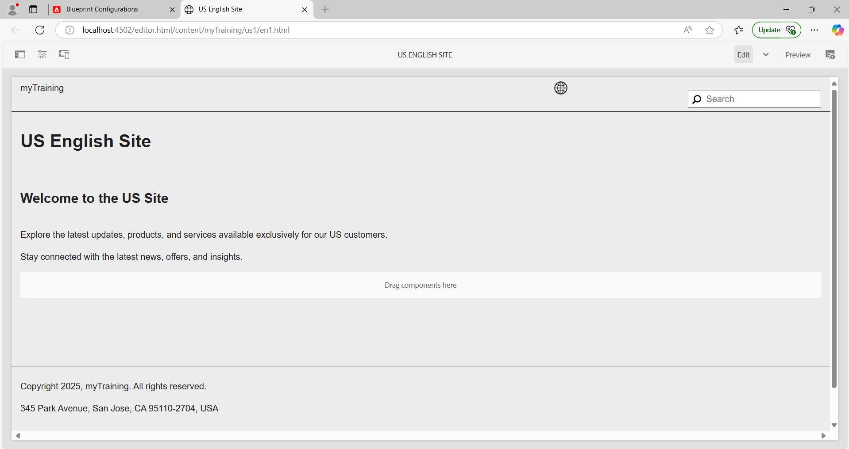

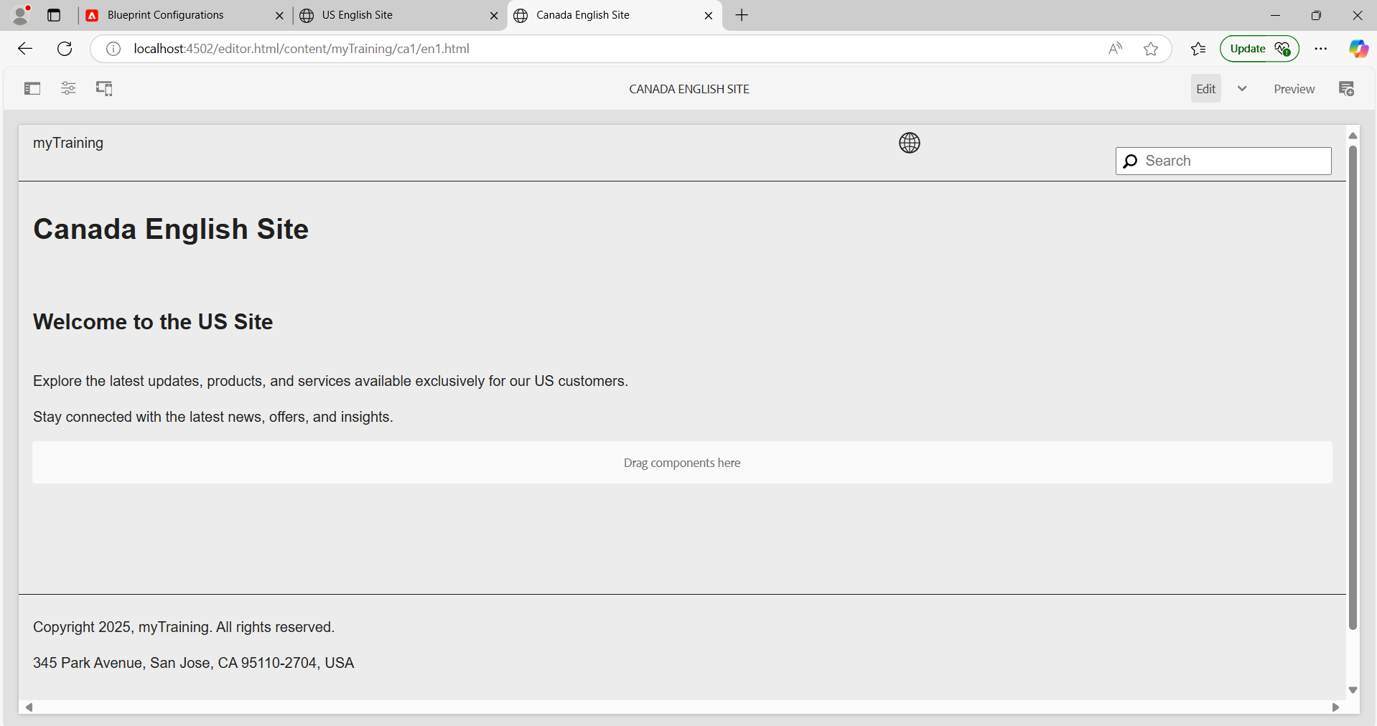

**4. Create this page** [**https://www.mcdonalds.com/us/en-us/about-our-food.html**](https://www.mcdonalds.com/us/en-us/about-our-food.html) **and author the page using components(using the content/images from the above page).**

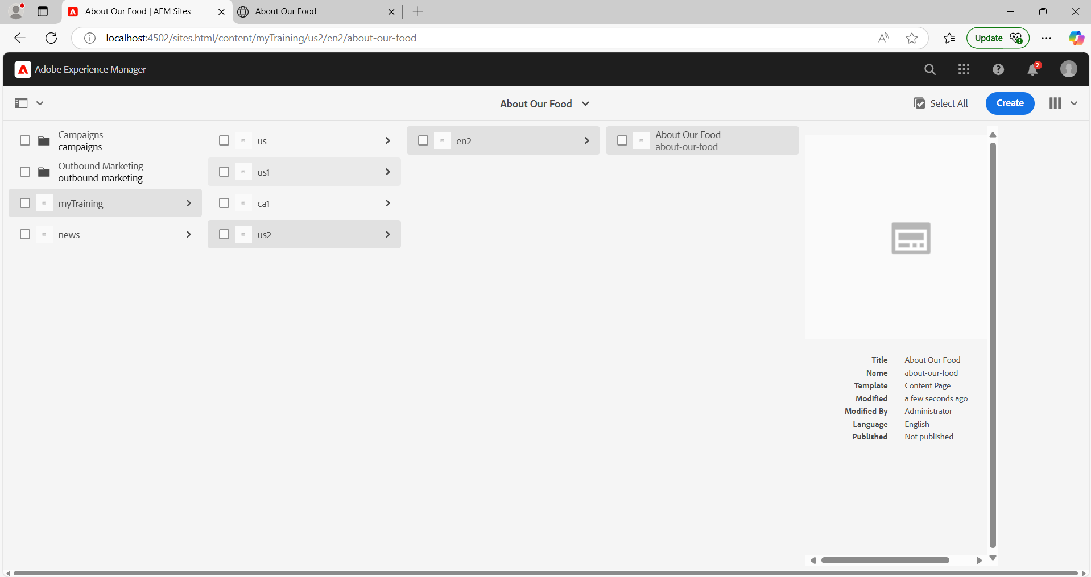

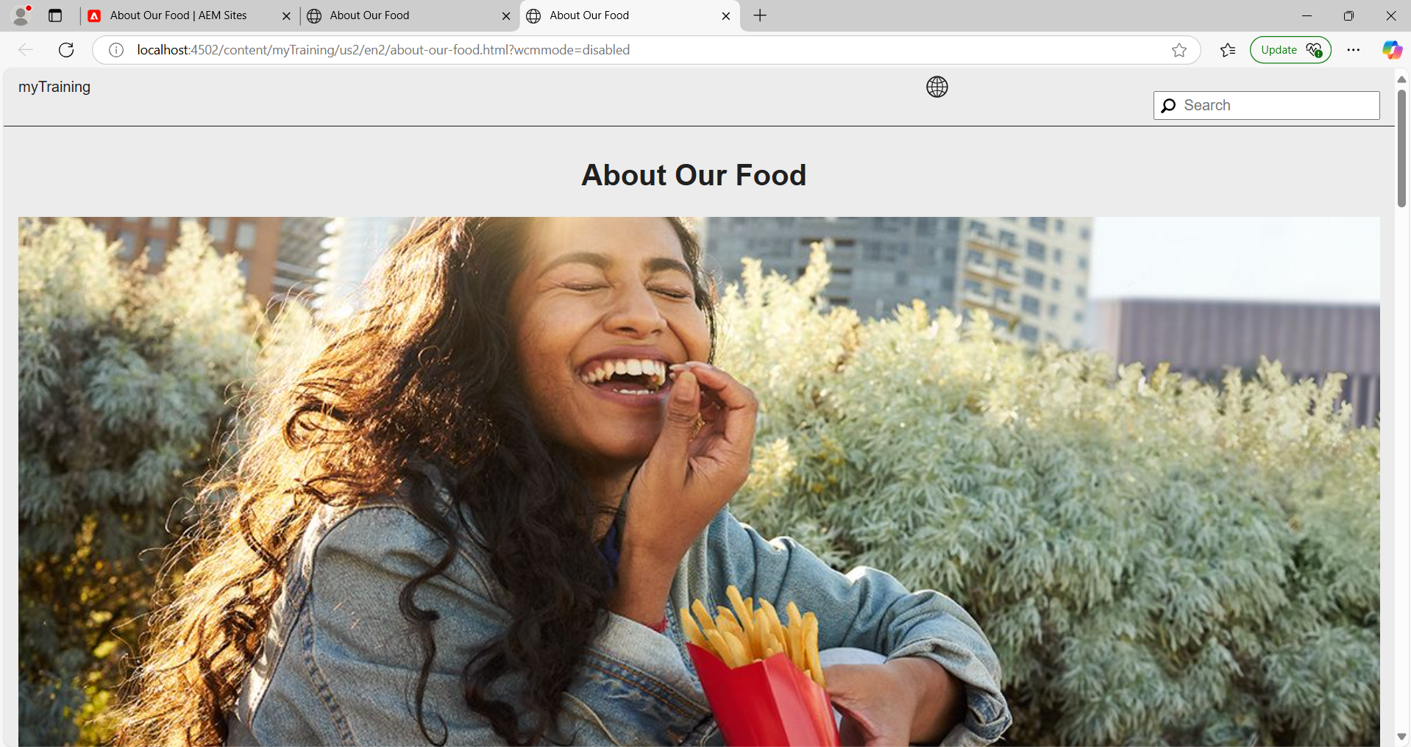

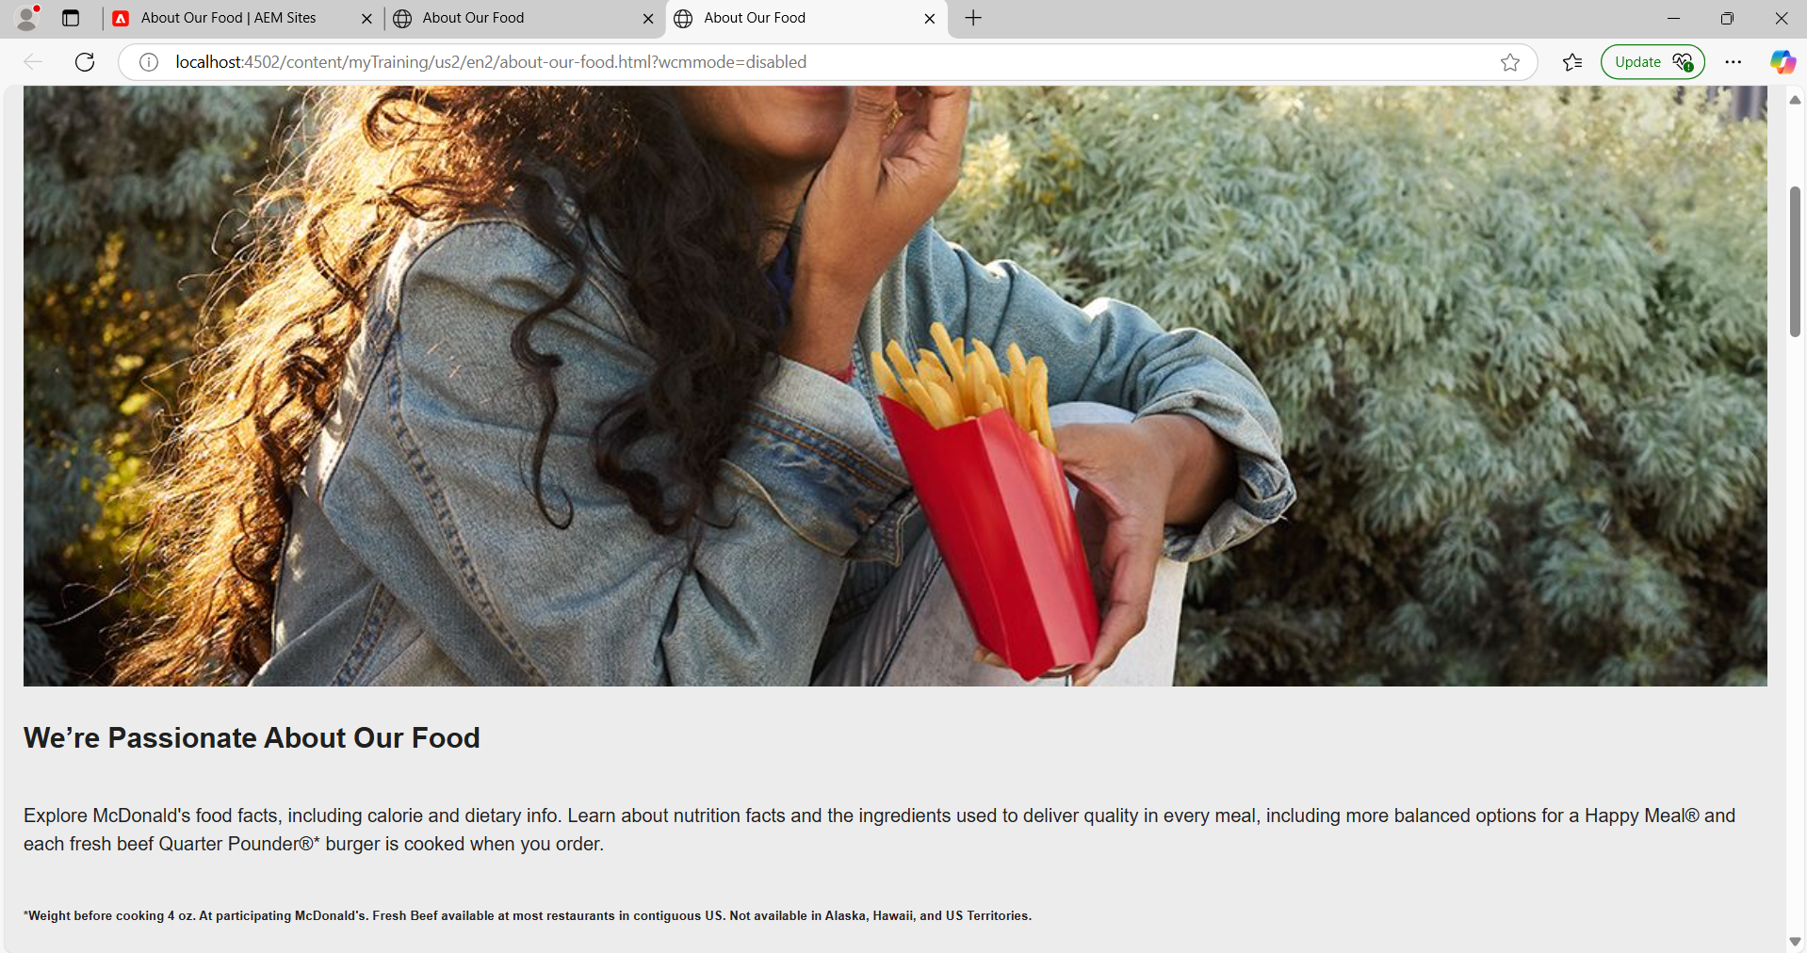

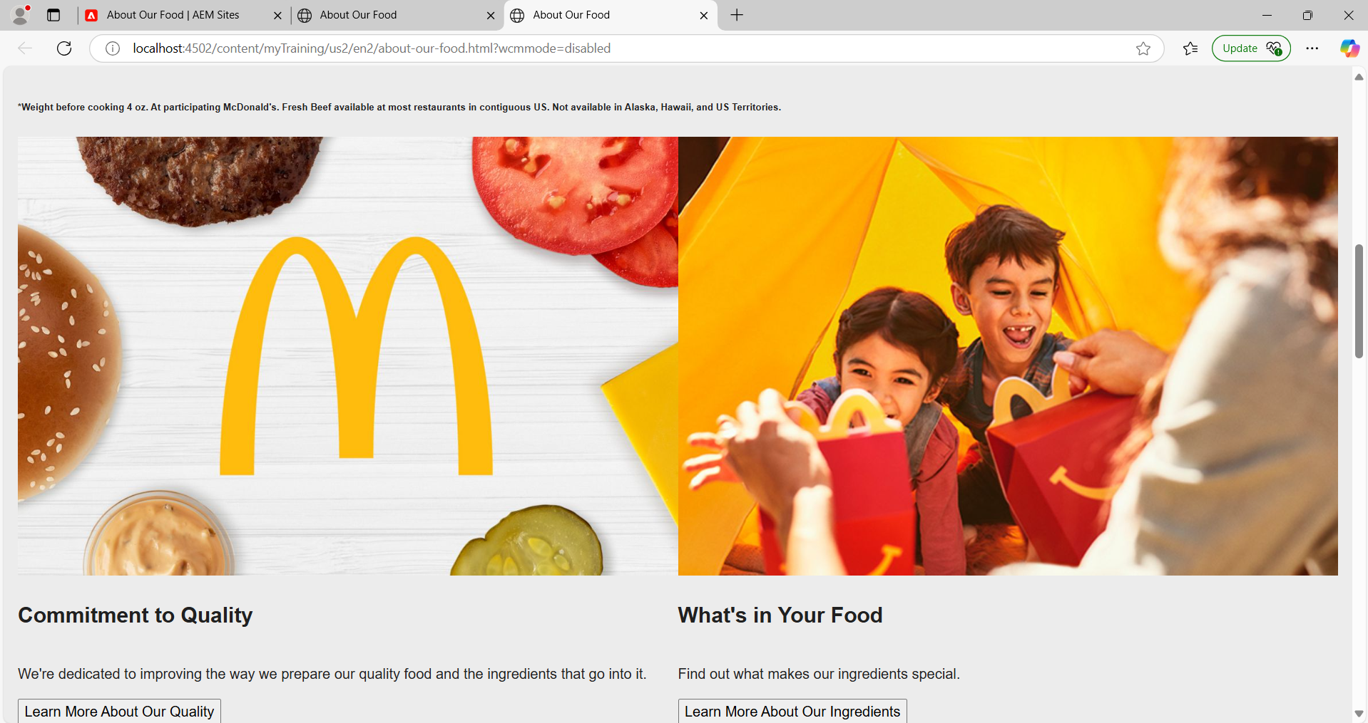

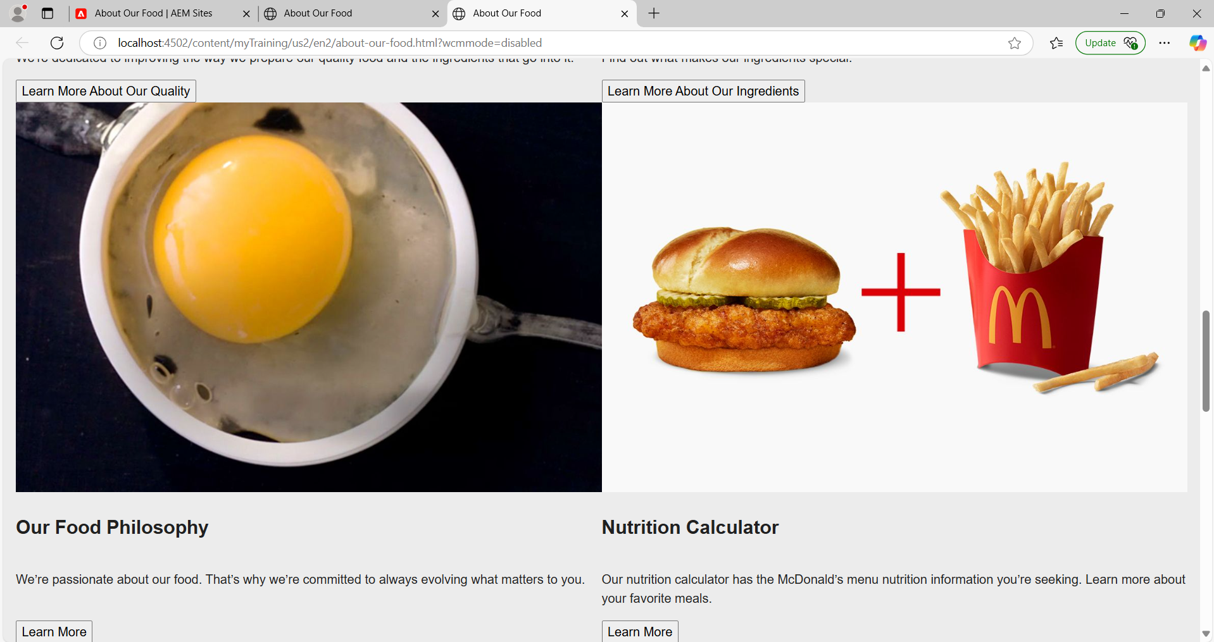

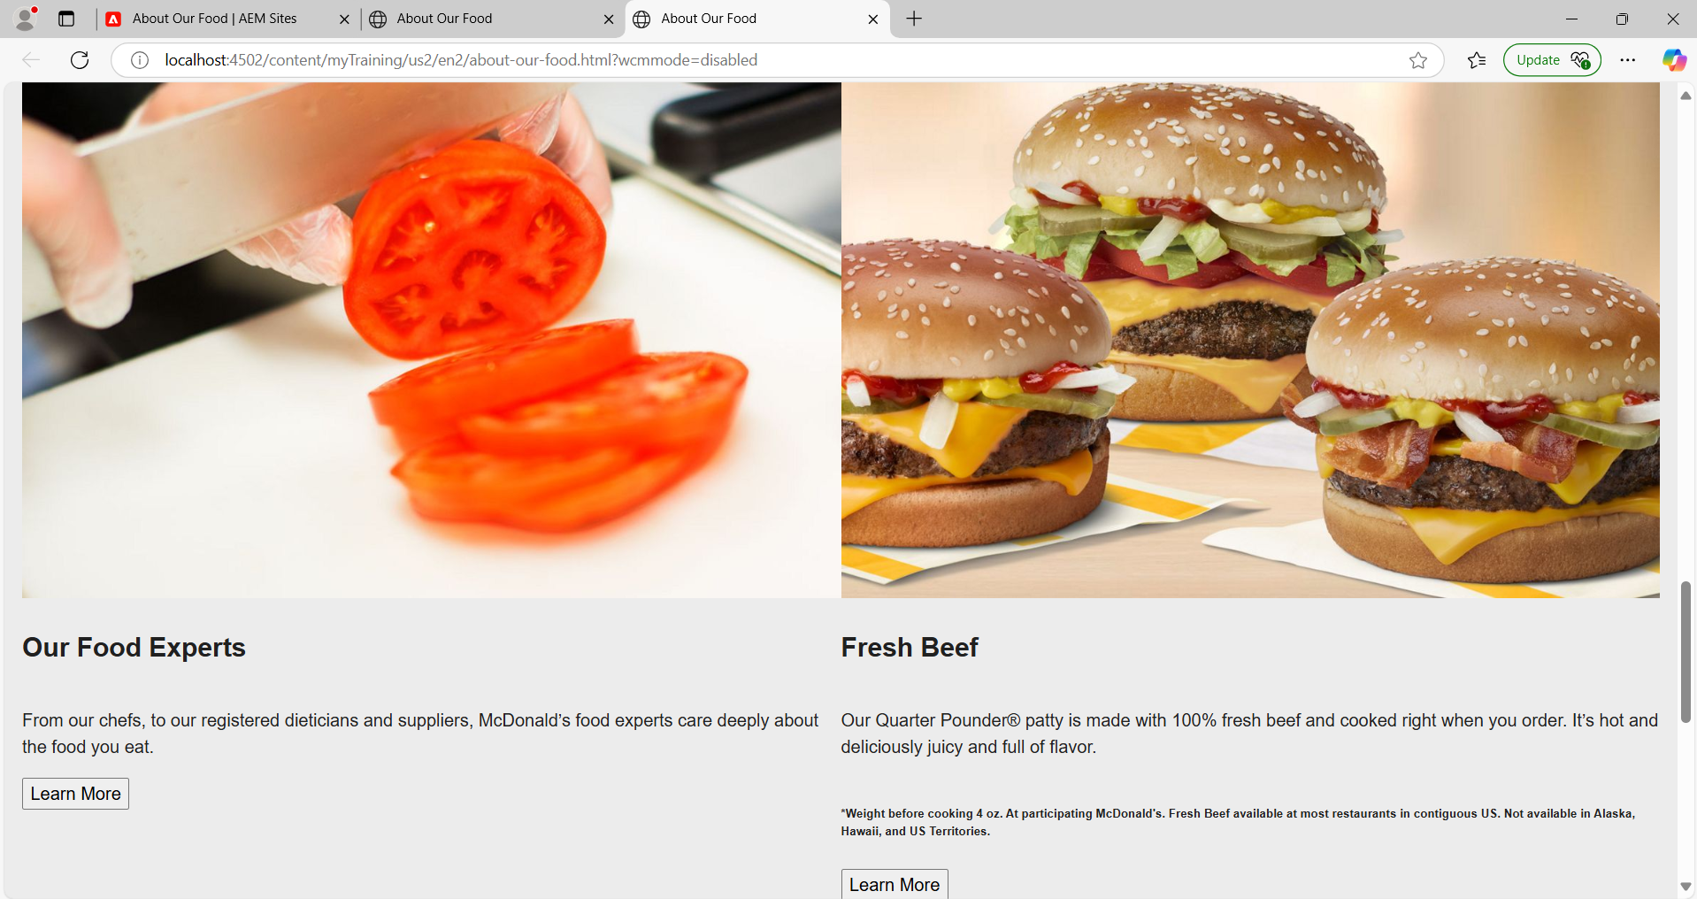

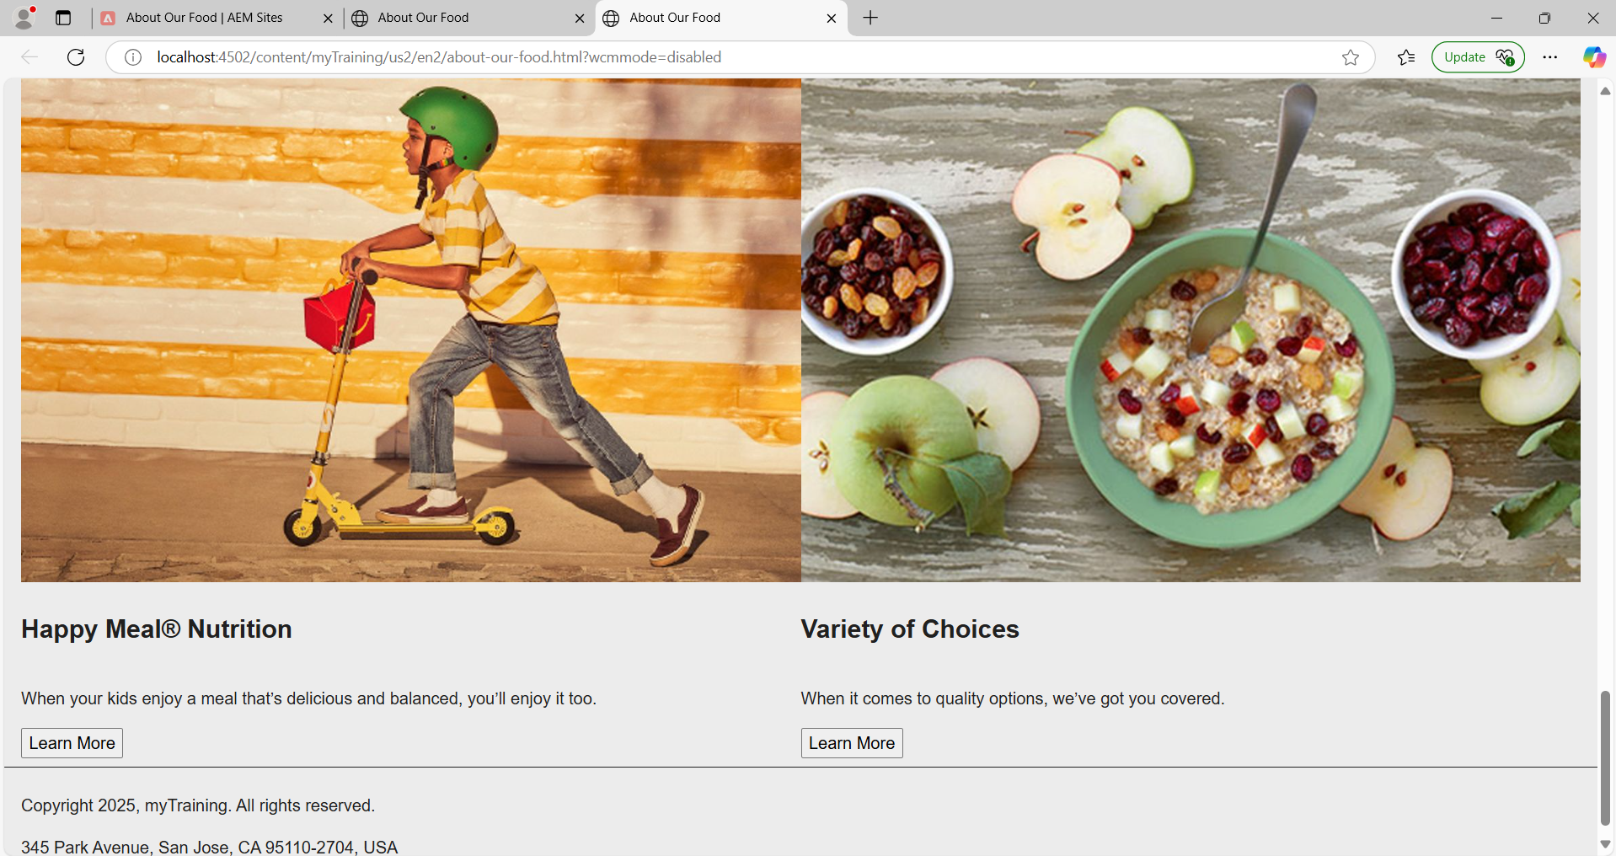

**5. Start the dispatcher on your local references.**

